2:1 Multiplexer Using Transmission Gates
Introduction:
Multiplexer (Mux) is a combinational circuit used to select one input signal from multiple input signals. It has 2^n inputs, 1 output and n select lines. We will implement a 2:1 mux using two transmission gates. It has two input lines, one select line and of course on output line.
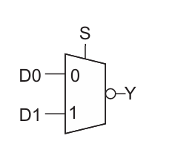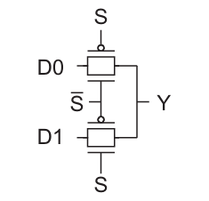
Image: 2:1 mux with inverted output Image: 2:1 mux using transmission gates
Truth table for mux with inverted output:
S | Y
0 | ~D0
1 | ~D1

Working:
When select line is set to logic 0, D0 is connected to the output and when select line is connected to logic 1, then D1 appears at the output. The mux we have implemented with transmission gates gives non-inverted outputs.
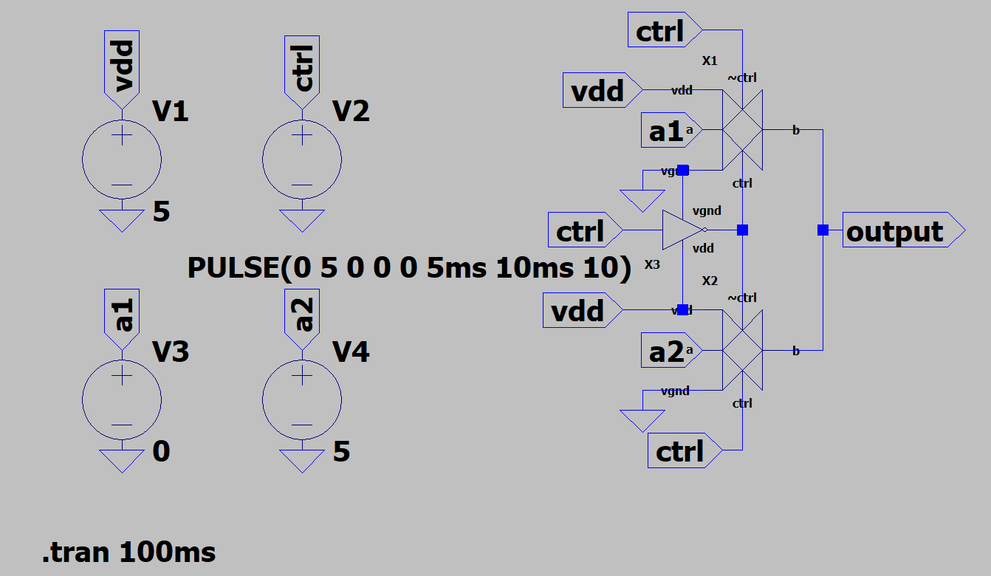
In above, circuit when ctrl signal is high, the second transmission gate turns on and input signal a2 appears at the output. When ctrl signal is low, then first transmission gate turns on and input signal a1 appears at the output.

Simulation result:
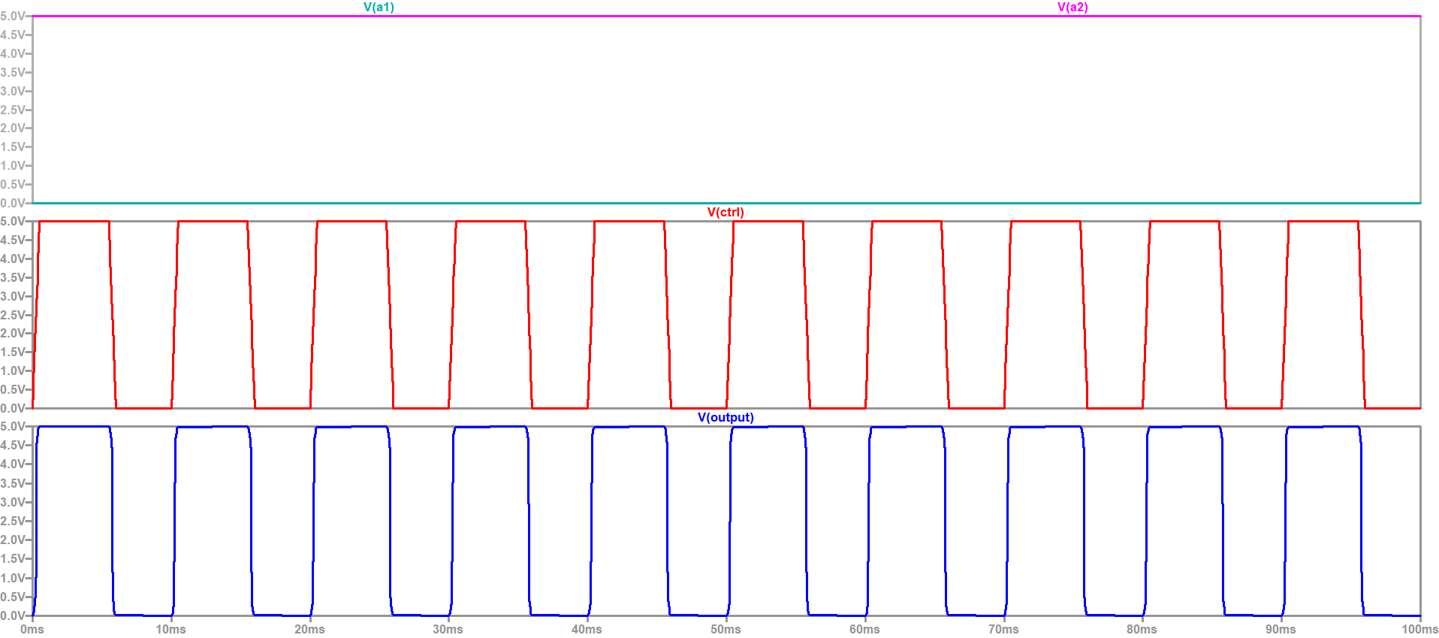
In simulation results, first wave form represents the signals a1 and a2. Second waveform represents the ctrl signal and third waveform represents the output.
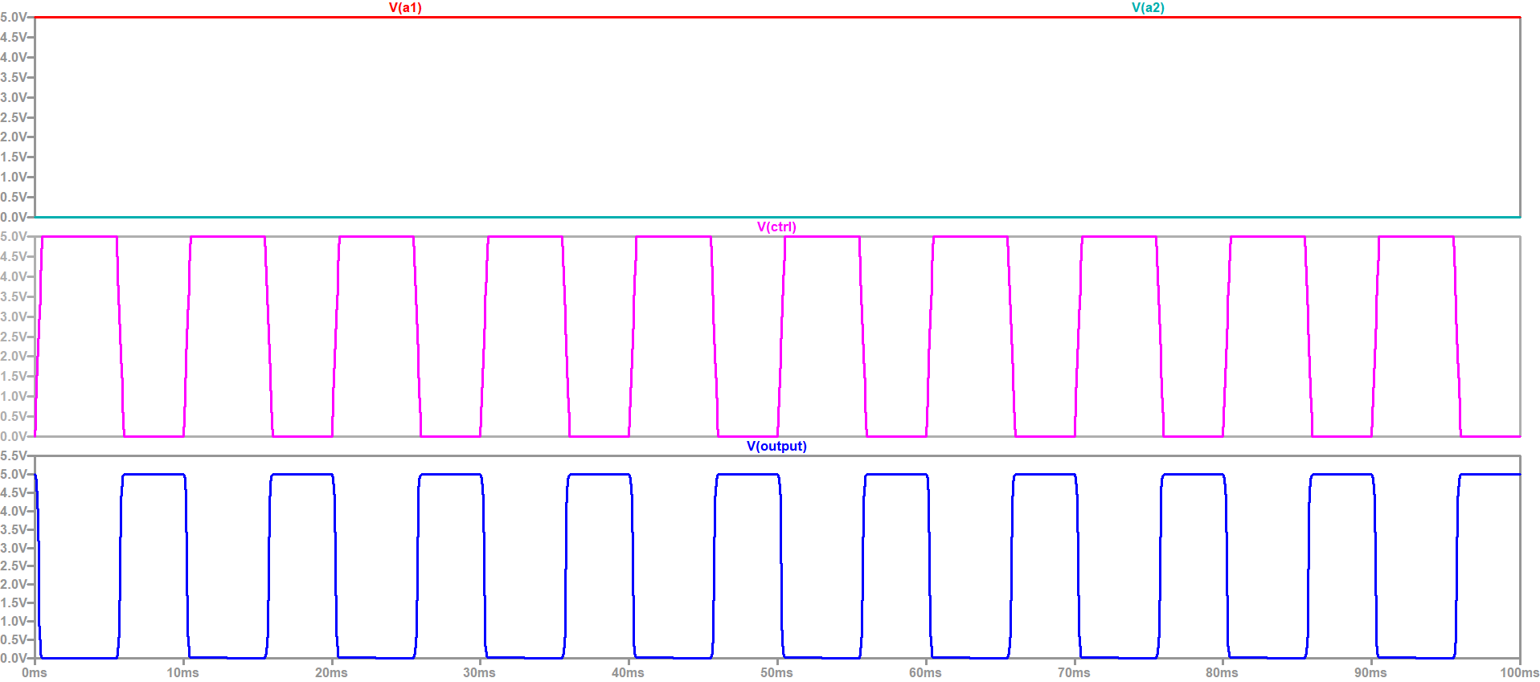
Inverted the input signals a1 and a2 and performed the simulation again. This time when ctrl signal goes low, a1 is selected, which is high hence, output goes high. When ctrl signal goes high, a2 is selected and output goes low.
There are different ways to design mux using CMOS with different benefits and trade offs. This is one of the method. Other methods include, implementation using compound gate or tristate inverters.

Author:
MADHUSUDAN

